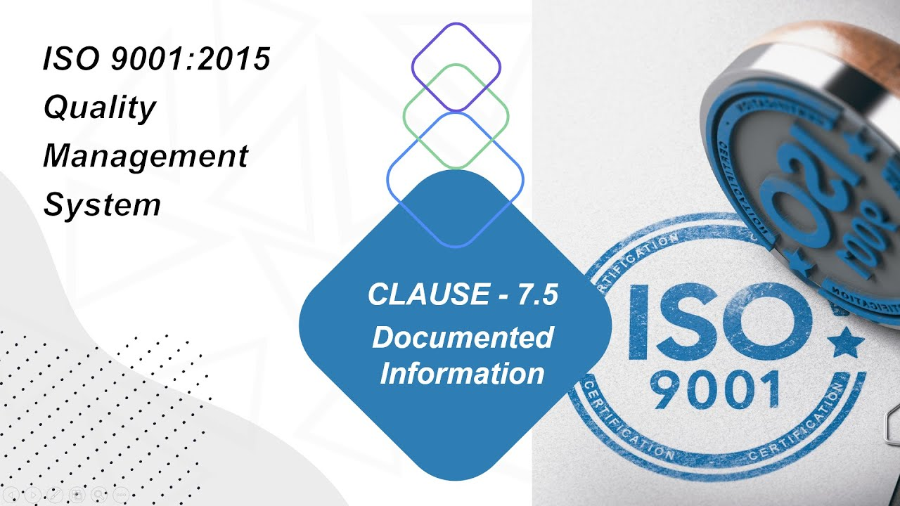

**What is Documented Information?**

Documented Information means information of the Organization and their internal functions. It’s depend on the size of the Organization and types of the activities, processes Products & Services secondly the complexity of the processes and their interactions

Communicable material which can be use to describe the process, system or procedure for describe the parts, assembly, maintenance etc.

**What are the requirements of this clause?**

Clause 7.5.1 General explains that the quality management system documentation shall include: documented information required by this International standard;

1. Requirements of the clause no. 4.1 – Internal / External Issues of the Organization
2. Requirements of the clause no. 4.2 – Needs & Expectations of the Interested Parties
3. Requirements of the clause no. 4.4 – Quality Management and Its processes, Inputs – process – output
4. Requirements of the clause no. 5.2 – Quality Policy
5. Requirements of the clause no. 5.3 – Role, Responsibility & Authorities of the employees
6. Requirements of the clause no. 6.1 – Identification of the Risk & Opportunities
7. Requirements of the clause no. 6.2 – Objectives and Action plan
8. Requirements of the clause no. 7.2 & 7.3 – Competency and Training
9. Requirements of the clause no. 7.4 - Communication in the Organization
10. Requirements of the clause no. 8 – Operations and Interactions of the processes
11. Requirements of the clause no. 9 – Internal Audit & MRM
12. Requirements of the clause no. 10 – Continual Improvement

7.5.2 – Creating and Updating

You may prepare the list of the documents and records as following to identify the documents number and retention and traceability.

|  |  |  |  |  |  |  |  |
| --- | --- | --- | --- | --- | --- | --- | --- |
| **9R-QA** | | **Quality Assurance Dept.** | | | | | |
| S. No | WI | Document Title | Doc. No. | Rev No. | Issue No. | Issue Date | Retention |
| QA 02 | 15.1 | In-coming material Quality plan | ELS-QAD-SOP-08 ,Annexure-01 | 00 | 01 | 20.01.18 | 3 Years |
| QA 03 | 15.2 | In-process material Quality plan | ELS-QAD-SOP-08 ,Annexure-02 | 00 | 01 | 20.01.18 | 3 Years |
| QA 04 | 15.3 | Finished product Quality plan | ELS-QAD-SOP-08 ,Annexure-03 | 00 | 01 | 20.01.18 | 3 Years |

**7.5.3 – Control of documented information**

Retention, Updating the information and disposition should control by system coordinator or HOD of the process. Otherwise there are hidden risks are behind the change control. Cycle of the document control shall be monitor by the process owners to maintain the effectiveness of the Quality Management System.

Hope this information will help you to understand the requirements of the clause 7.5. For further details you may visit our website and read another articles related to the ISO 9001:2015.